**Database Project: Pokemon**

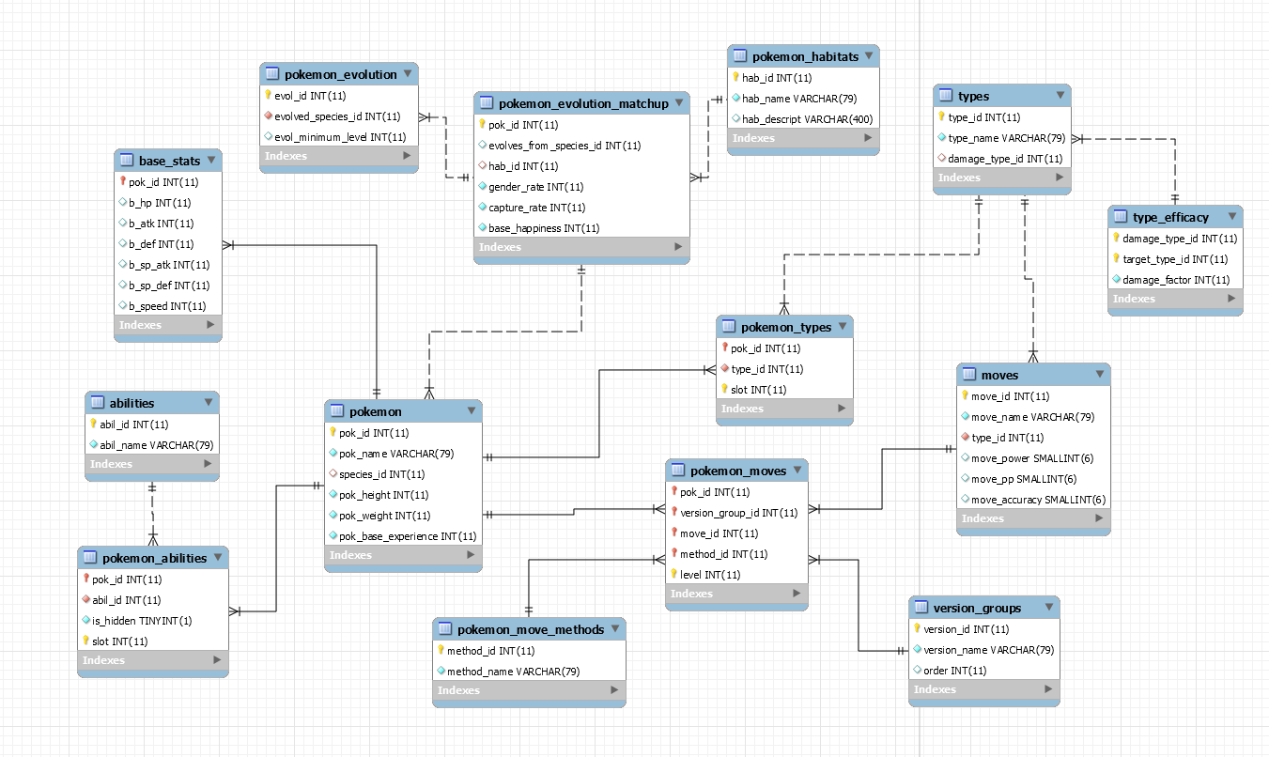

**Views**

1. **View of Pokémon with attack, defense, and hp greater than 100.**

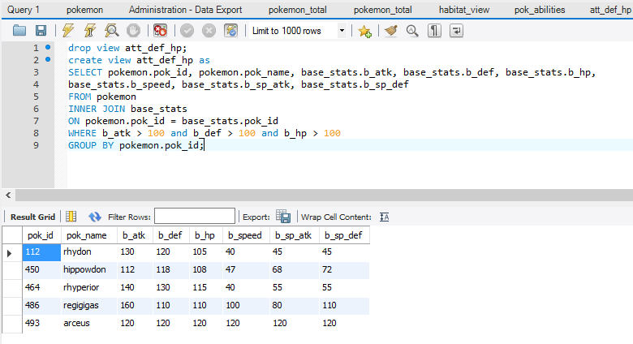

1. **View of Pokémon and their habitat.**

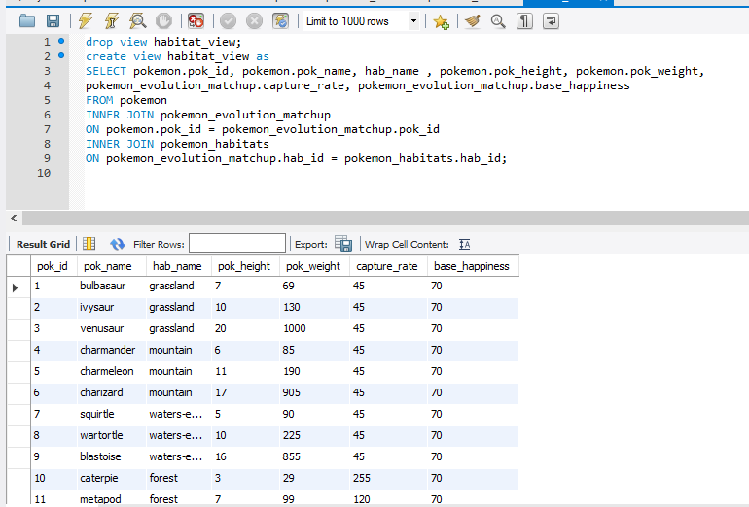

1. **View of Pokémon and all of their abilities.**

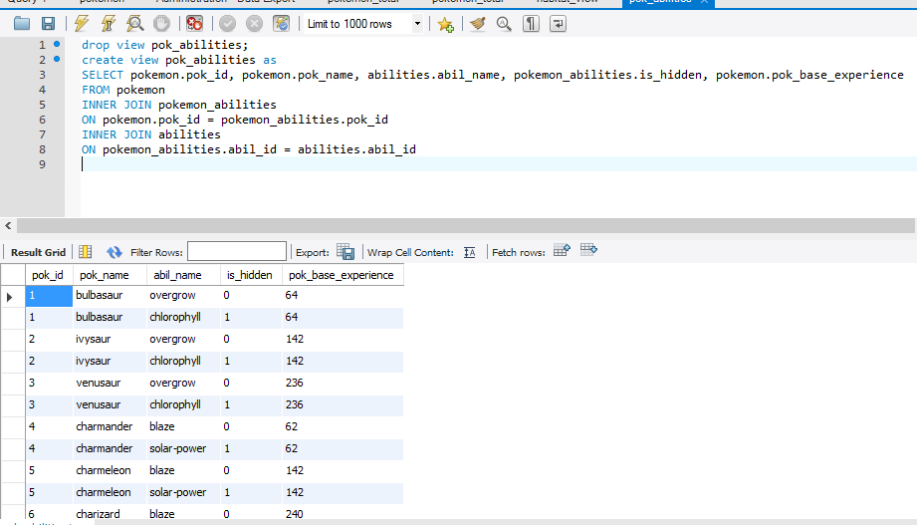

1. **View of the sum of all Pokémon base stats.**

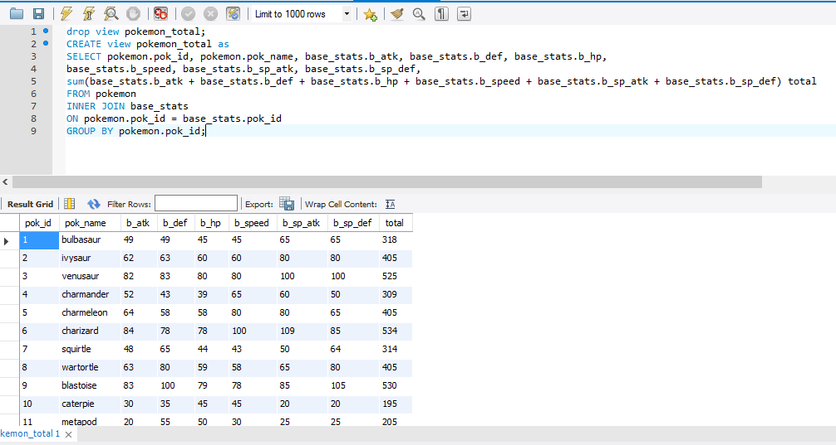

1. **View of the top 10 Pokémon total base stats.**

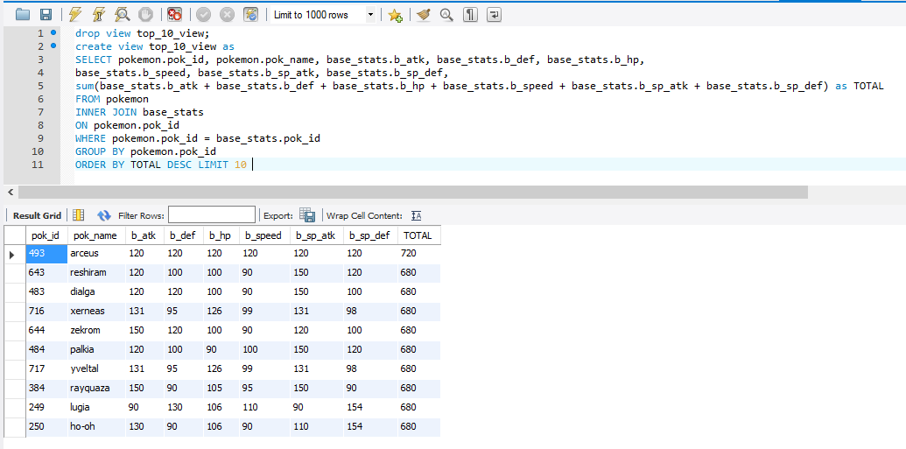

**Stored Procedures**

1. **Input a Pokémon’s name and returns their abilities.**

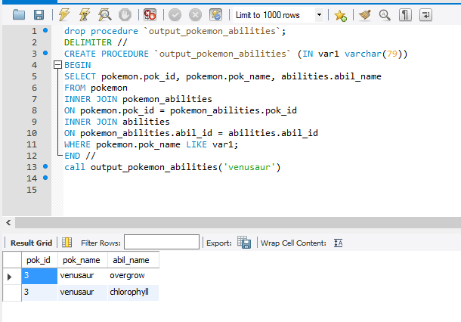

1. **Input a Pokémon’s name and returns all their base stats.**

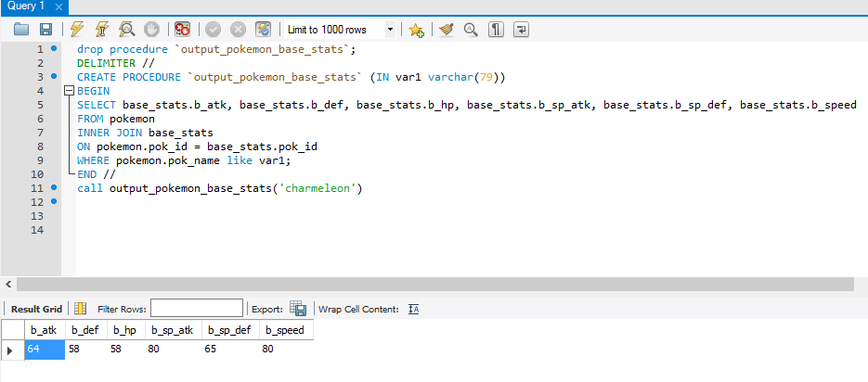

1. **Input a Pokémon’s id and returns their name and evolution.**

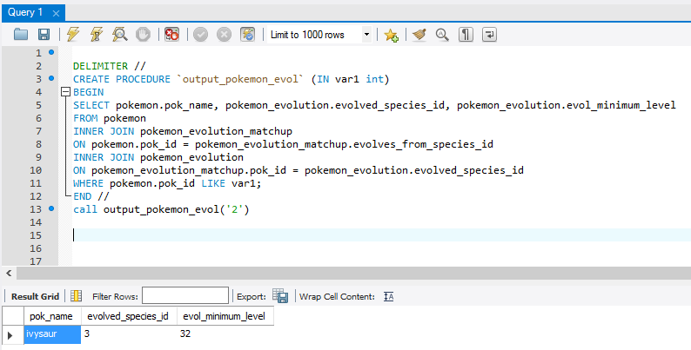

1. **Input a move and Pokémon name. If there is a return then the Pokémon has fainted. If there is no return then the Pokémon did not faint.**

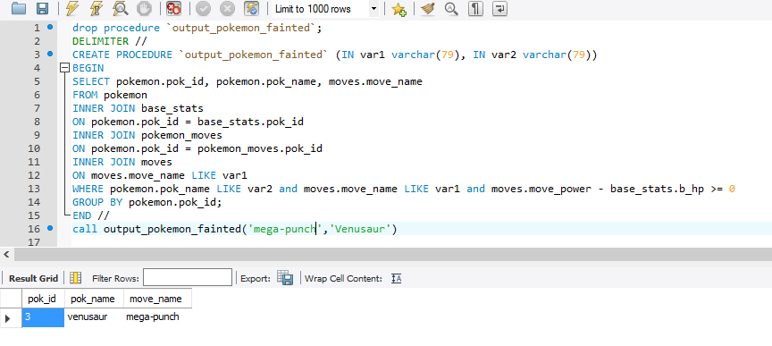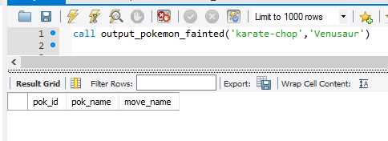

1. **Input a habitat and returns all the Pokémon in that habitat.**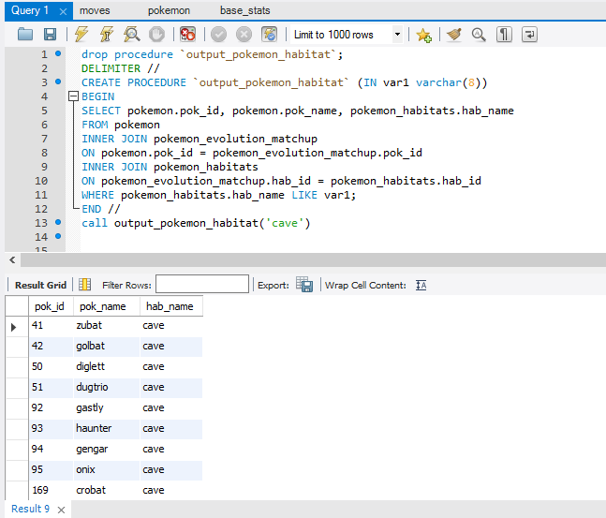
2. **Input a Pokémon name and return their hidden ability.**

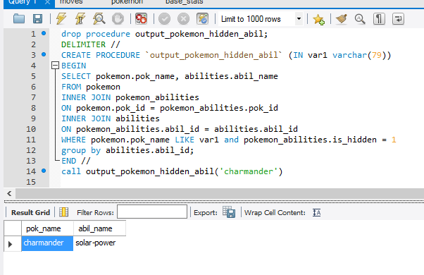

1. **Input a Pokémon’s name and return all their moves.**

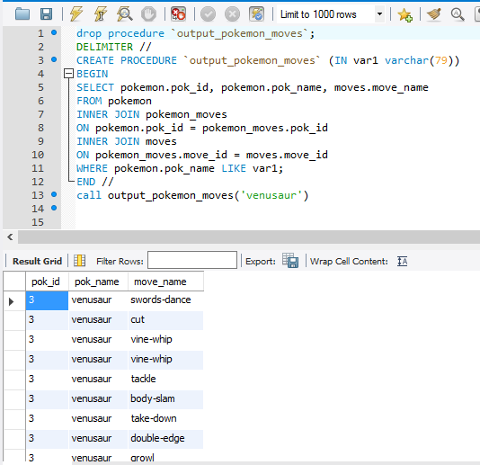

1. **Input a Pokémon move and returns how a Pokémon can learn that move.**

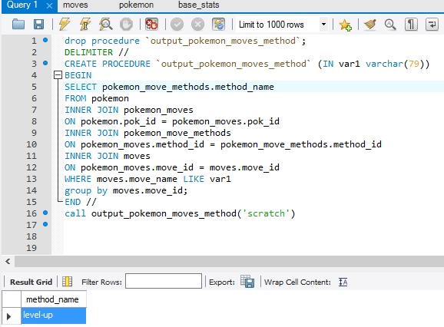

1. **Input a Pokémon move and return the type that move is.**

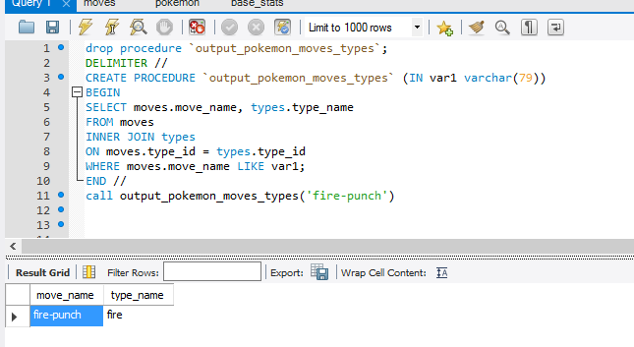

1. **Input a move and return the game version of the move.**

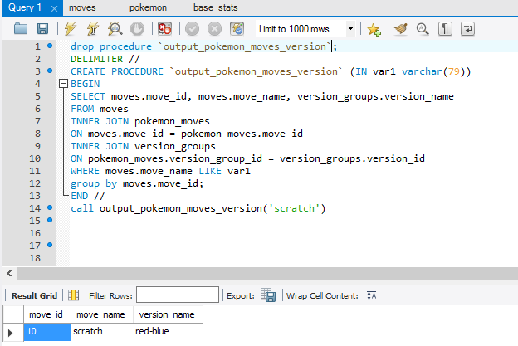

1. **Input a type and return the damage factor.**

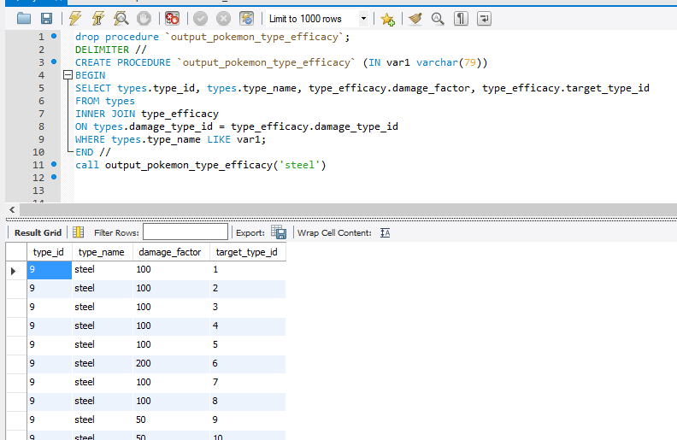

1. **Input a Pokémon’s name and return their type.**

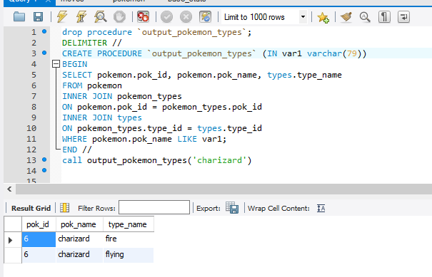

**Triggers**

1. **If insert for height, weight, or base experience is negative than it will be set to 0.**

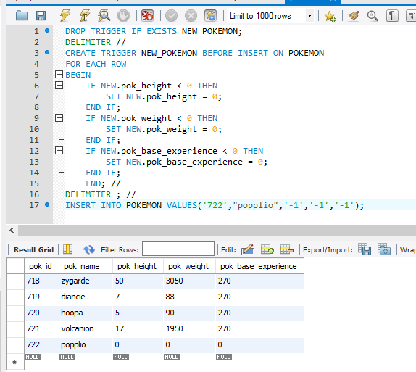

1. **If the insert for habitat name and description is empty then it is set to Unknown.**

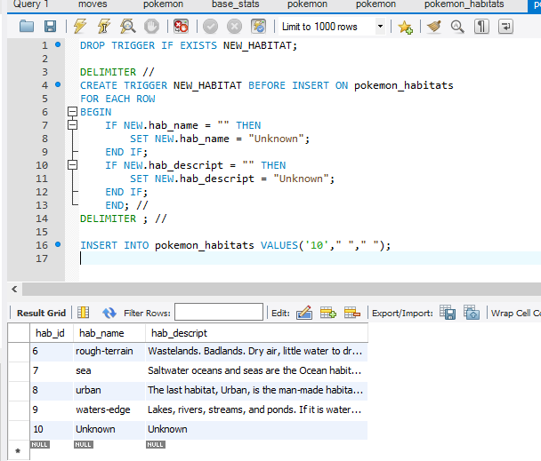

1. **The insert for hidden ability needs to be 0 or 1, or will be set to 0.**

**The insert for slot needs to be 1,2, or 3 or else it will be set to 1.**

